

CSE302: Database Systems (01)
[Summer 2024]

Project Report

Paris Olympics 2024

https://apex.oracle.com/pls/apex/r/delulu_girls/parisolympic2024

Submitted by:

Student ID | Student Name | Contribution Percentage
2022-3-60-110 | Atkiya Maisha | 54%
2022-3-60-112 | Mohua Akter | 46%

E-R Model of the Project

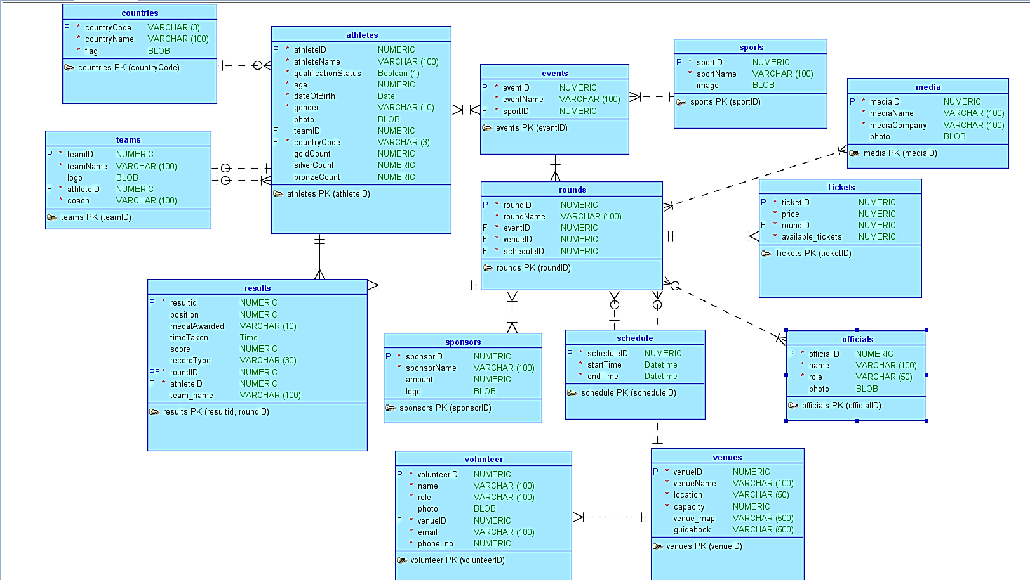

Relational Data Model of the Project

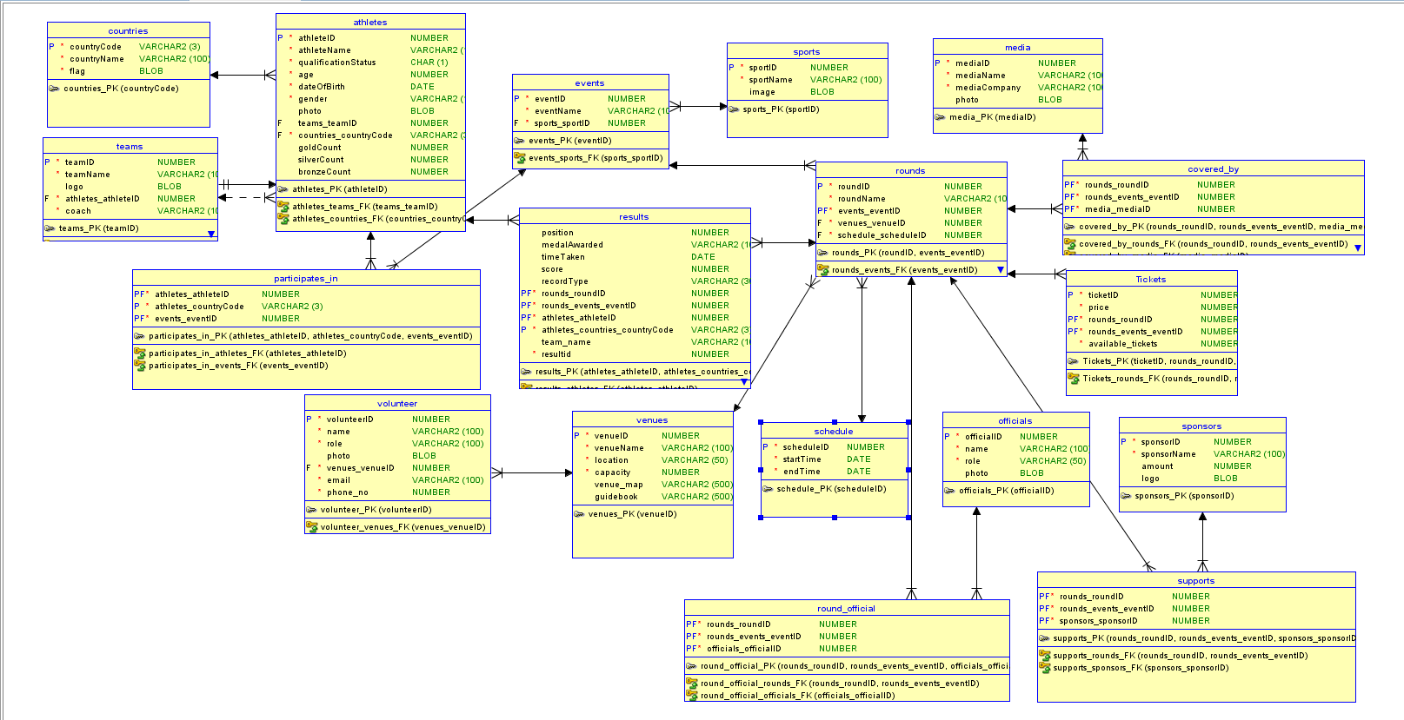

Implementation Checklist

Description | Remarks
Project ID | 35029
Workspace Name | DELULU_GIRLS
Workspace Email | 2022-3-60-110@std.ewubd.edu
Workspace Password | lordthegreat
Authentication Type | Custom (custom_auth)
Username and Password to Login
admin | lemmein
manager | lemmein
reader | lemmein
Uploaded and Displayed Images in Reports | yes
Implemented Page-wise Authorization | yes
Number of Reports with Forms | 18
Number of Master-detail Forms | 5
Number of Reports based on Queries, Aggregate Queries | 3
Number of Parameterized Reports | 1
Number of Graphs/Charts | 1 (Four graphs in one Dashboard)
Included any trigger/other feature which is not taught in class. If yes, please explain briefly. | - Multiple Triggers  - Custom CSS for login and home page  - HTML for buttons and links (used in Venue map)  - Action buttons for page navigation
Write the most unique feature/functionality in your application or the page of your application that you are proud of. Explain briefly. | We explored various features, including custom colour schemes, different page types like calendar and dashboard, and extensively used properties in page design, including CSS and HTML for customization. We also changed the navigation bar style and added icons for a more polished look. We also created a system through which a user can book tickets and see available tickets.

Reports with Forms

Report Page Number and Name | Form Page Number and Name | Table
Officials - 2 | Official form - 3 | officials
Athlete_info -4 | Athlete_form - 5 | Athletes
Country_info – 6 | Country_form - 7 | Countries
Sponsors - 9 | Sponsors form – 10 | Sponsors
Event_info - 12 | Event_form - 13 | Events
Round_info -14 | Round_form - 15 | Rounds
Sports_info - 18 | Sports_form -19 | Sports
Venue_info - 20 | Venue_form - 21 | Venues
Volunteer_info - 22 | Volunteer - 23 | Volunteer
Tickets - 26 | Ticktet - form - 34 | Tickets
team_info - 27 | team_form - 28 | Teams
Schedule_info - 32 | Schedule_form - 33 | Schedule
Results - 36 | result_form - 37 | Results
athletes event participation - 44 | Athletes event participation  form - 45 | participates_in
supports - 47 | supports_form - 48 | supports
cover_by_info - 51 | cover_by_form - 52 | Covered_by
Media_info - 55 | Media_form - 56 | Media
Round Officials - 74 | Round officials form - 75 | round_official

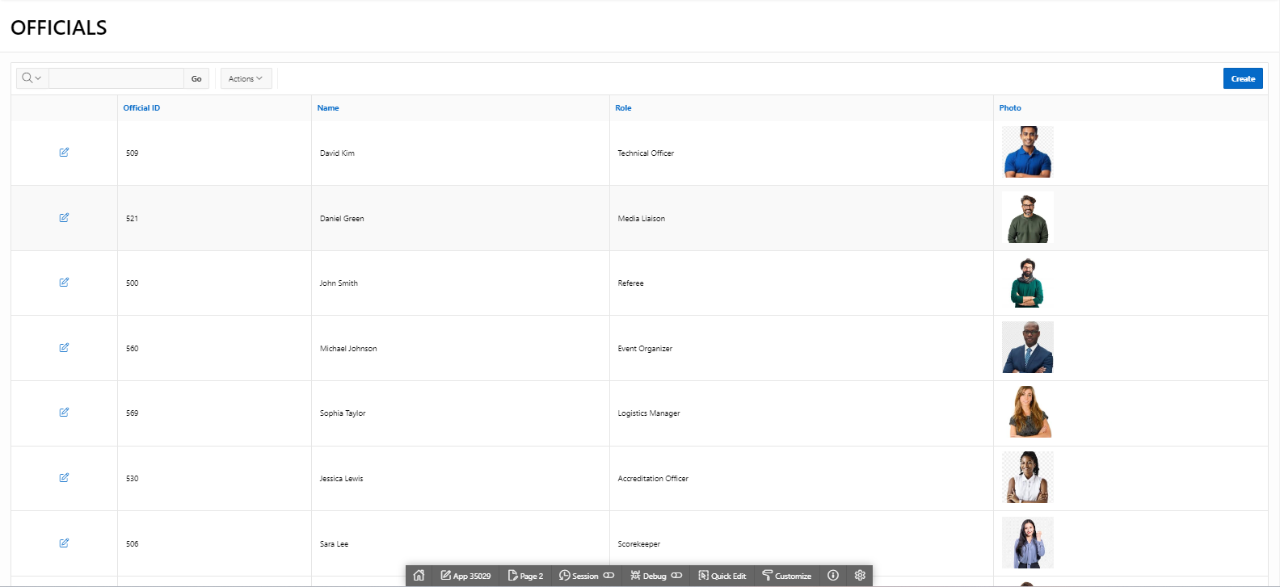
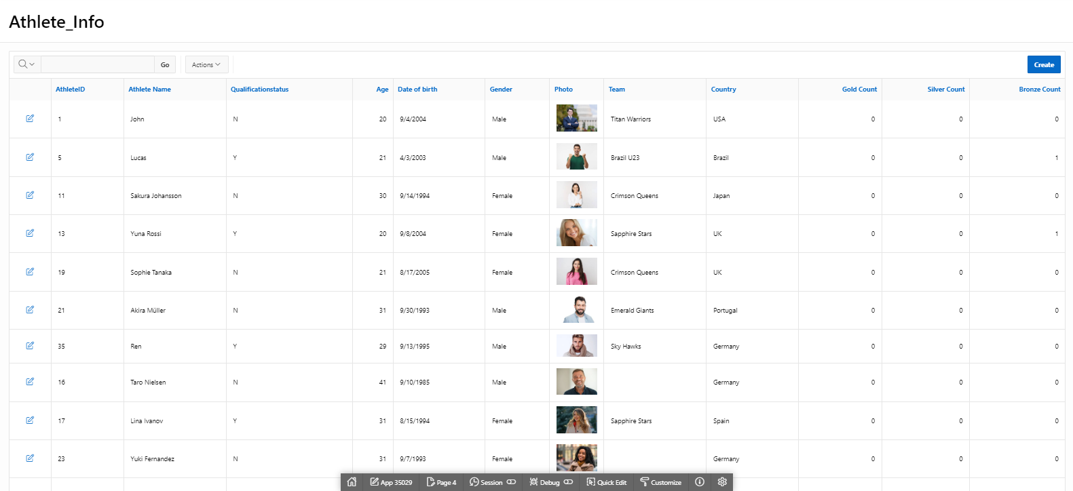
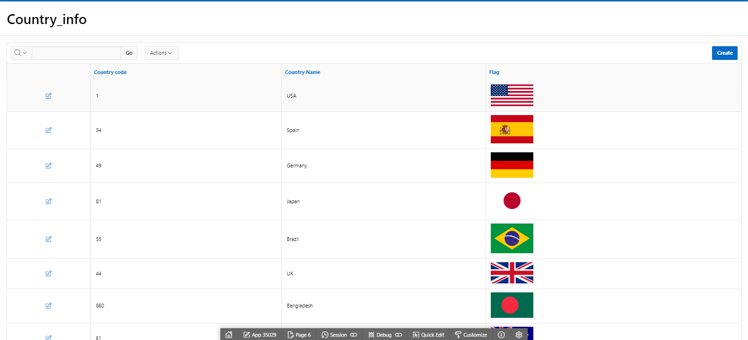
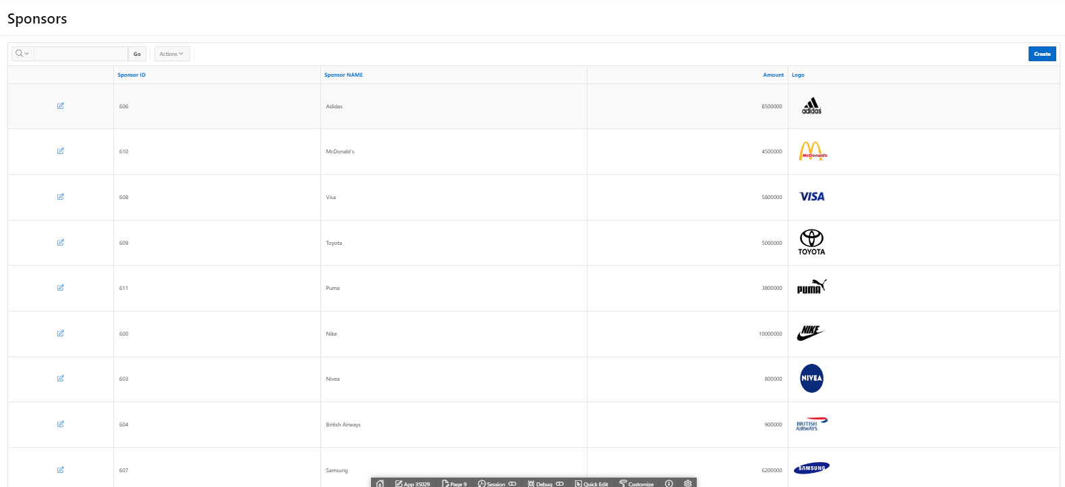
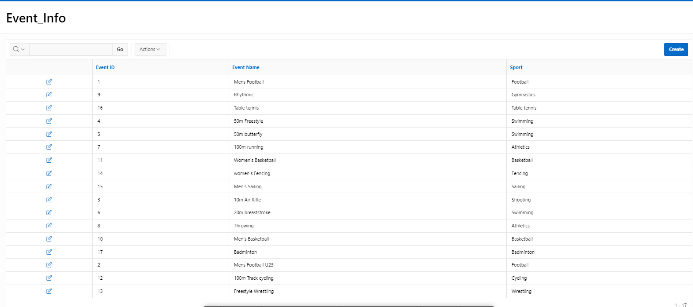
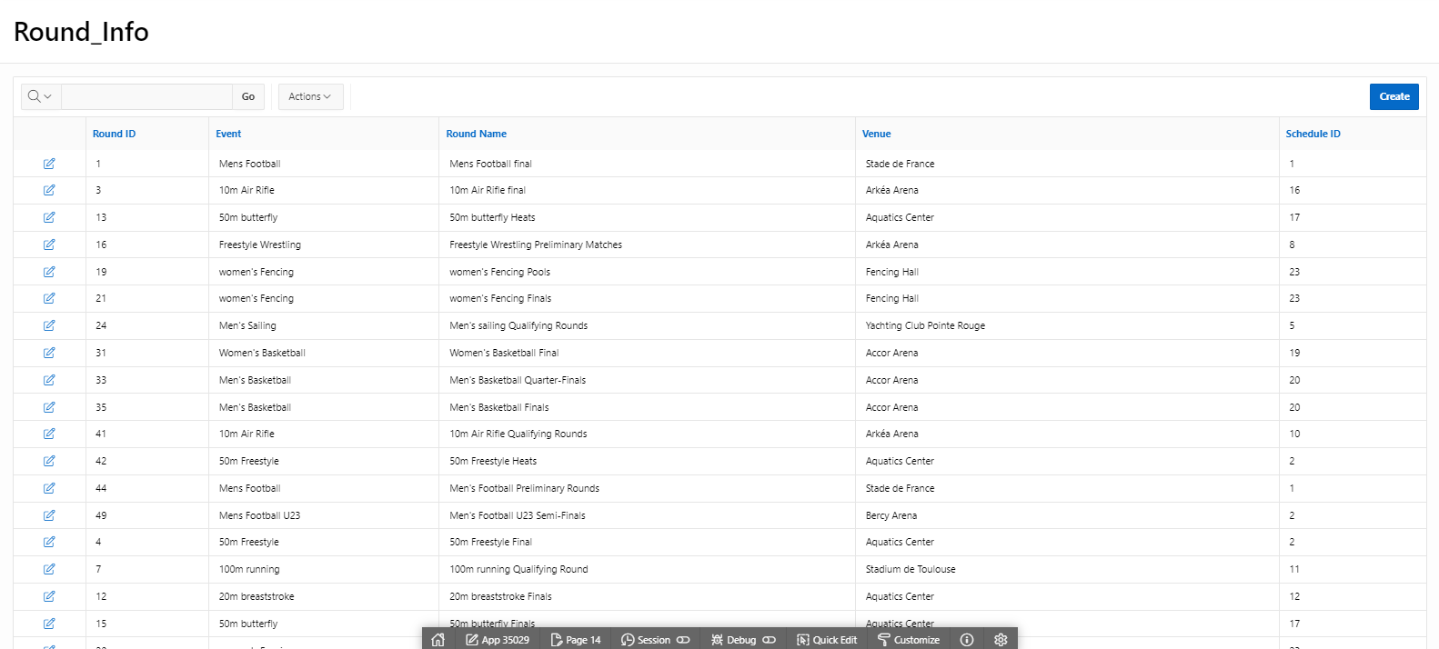
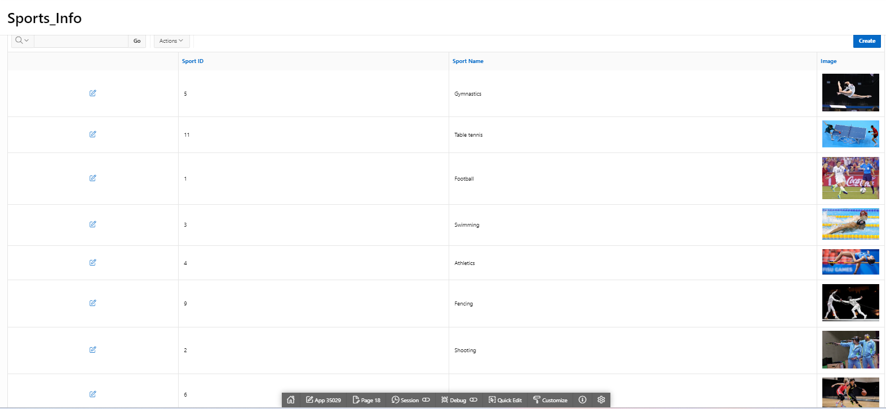
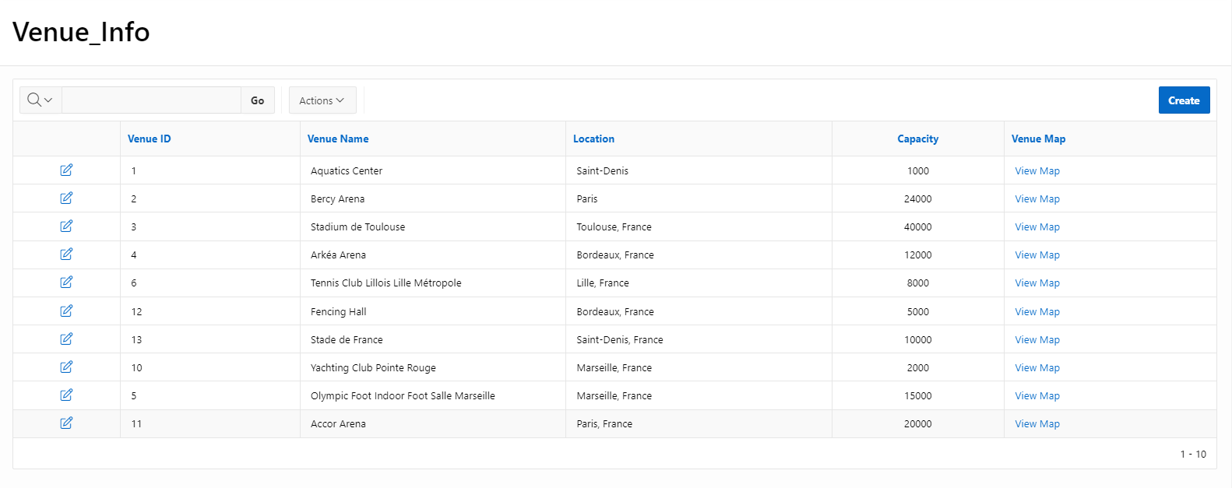
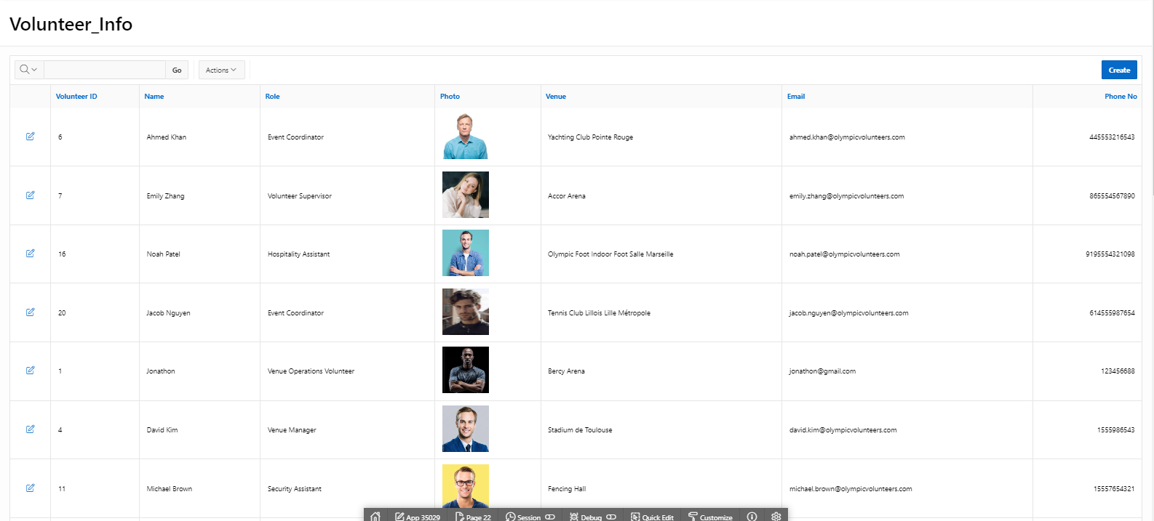
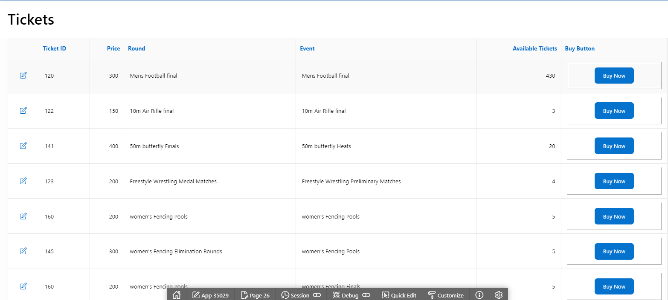

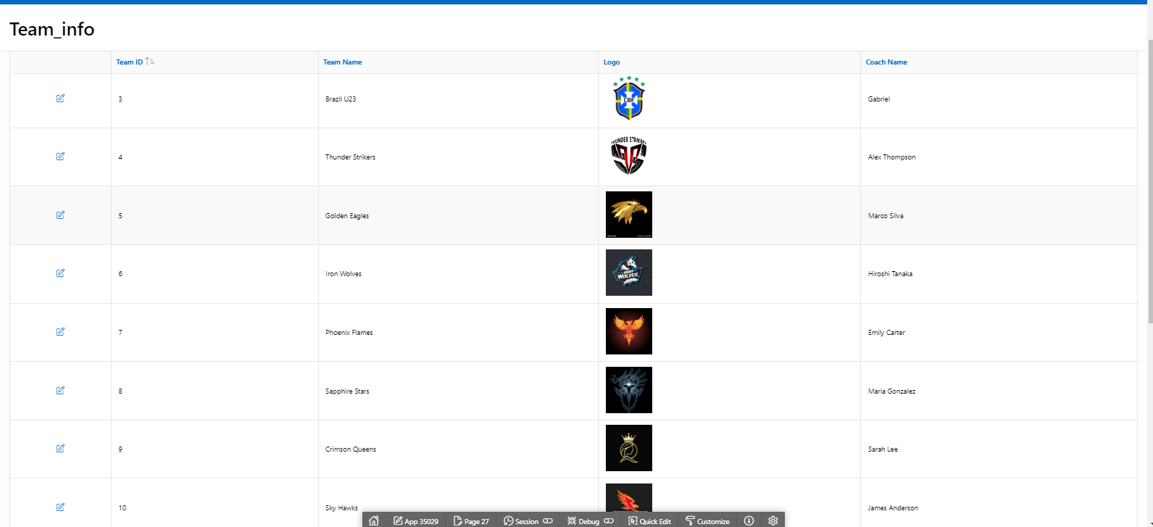
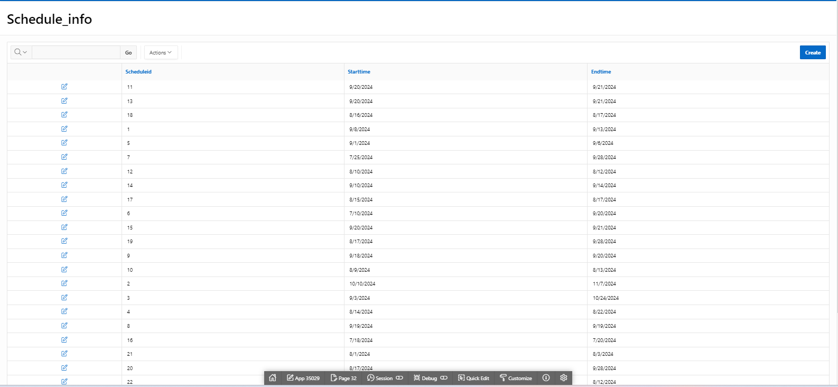
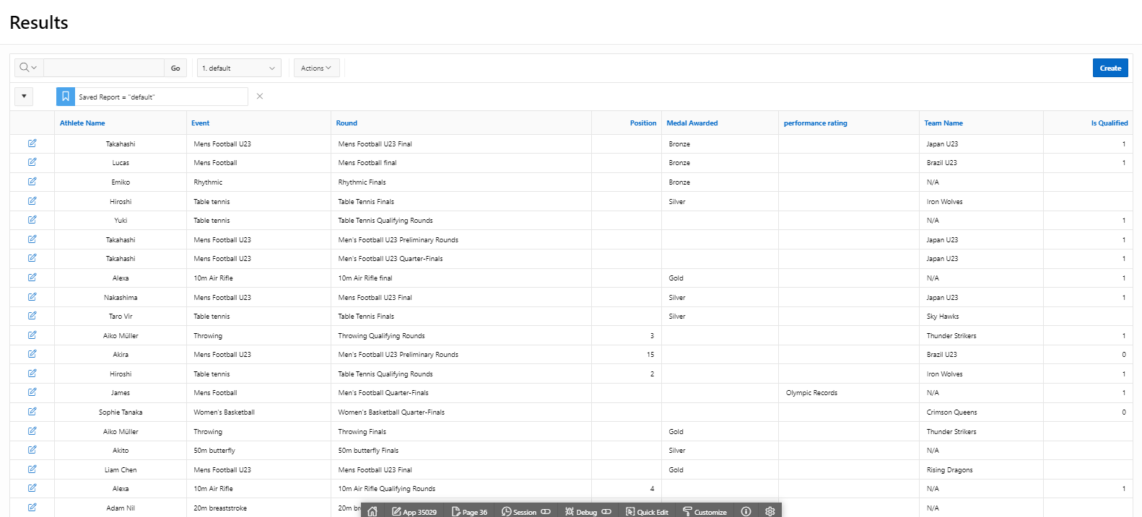
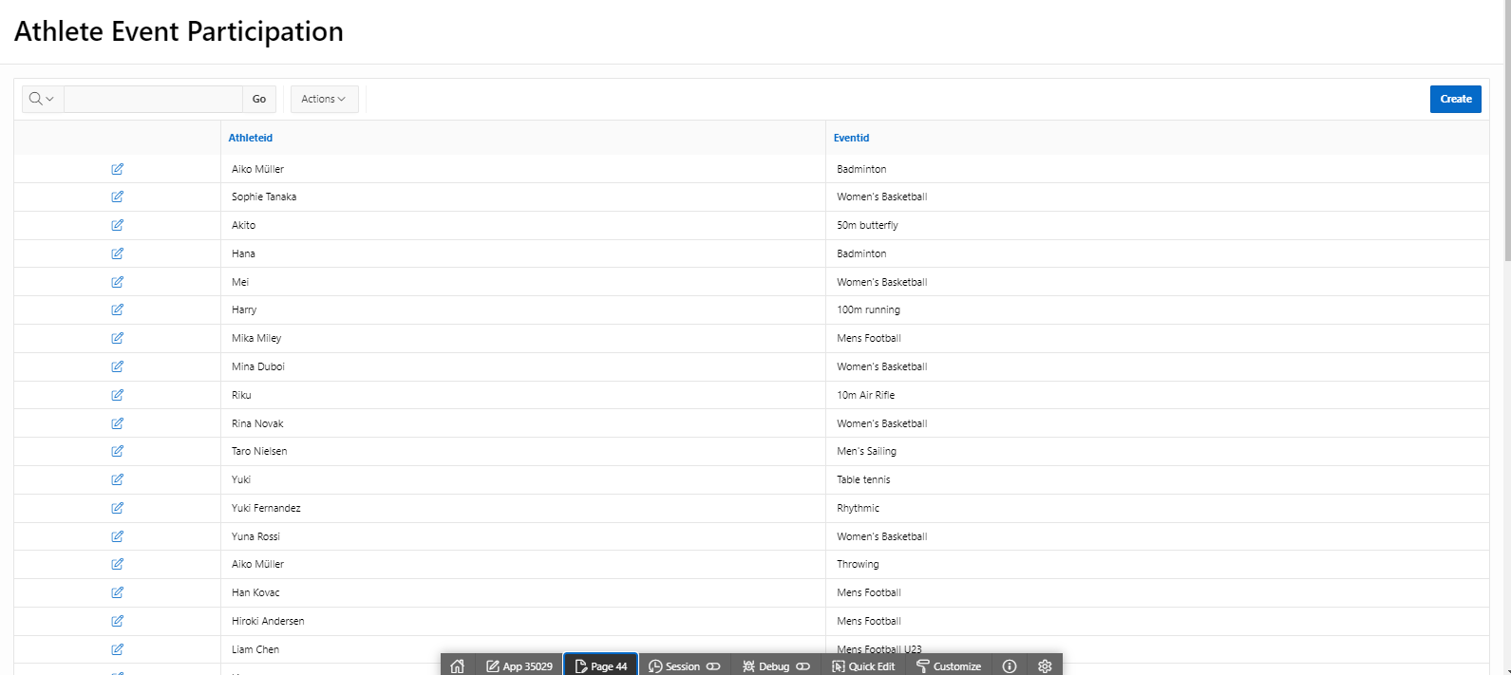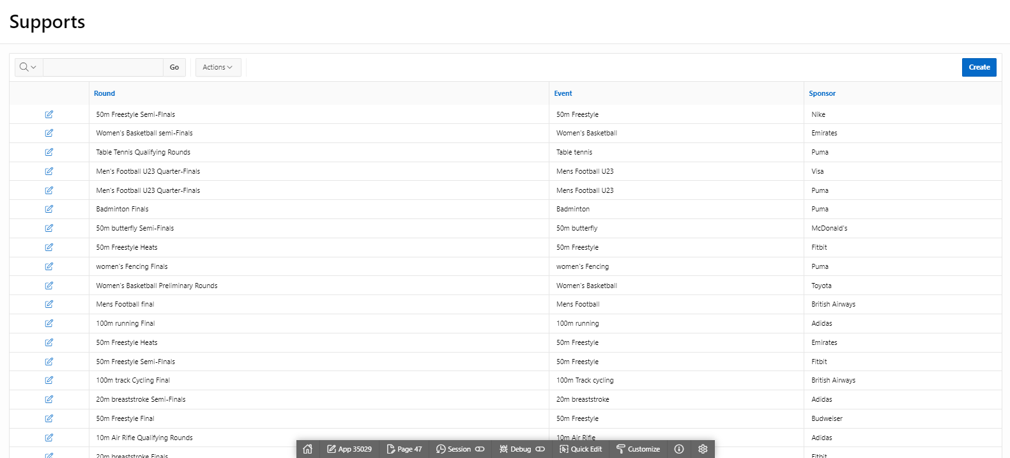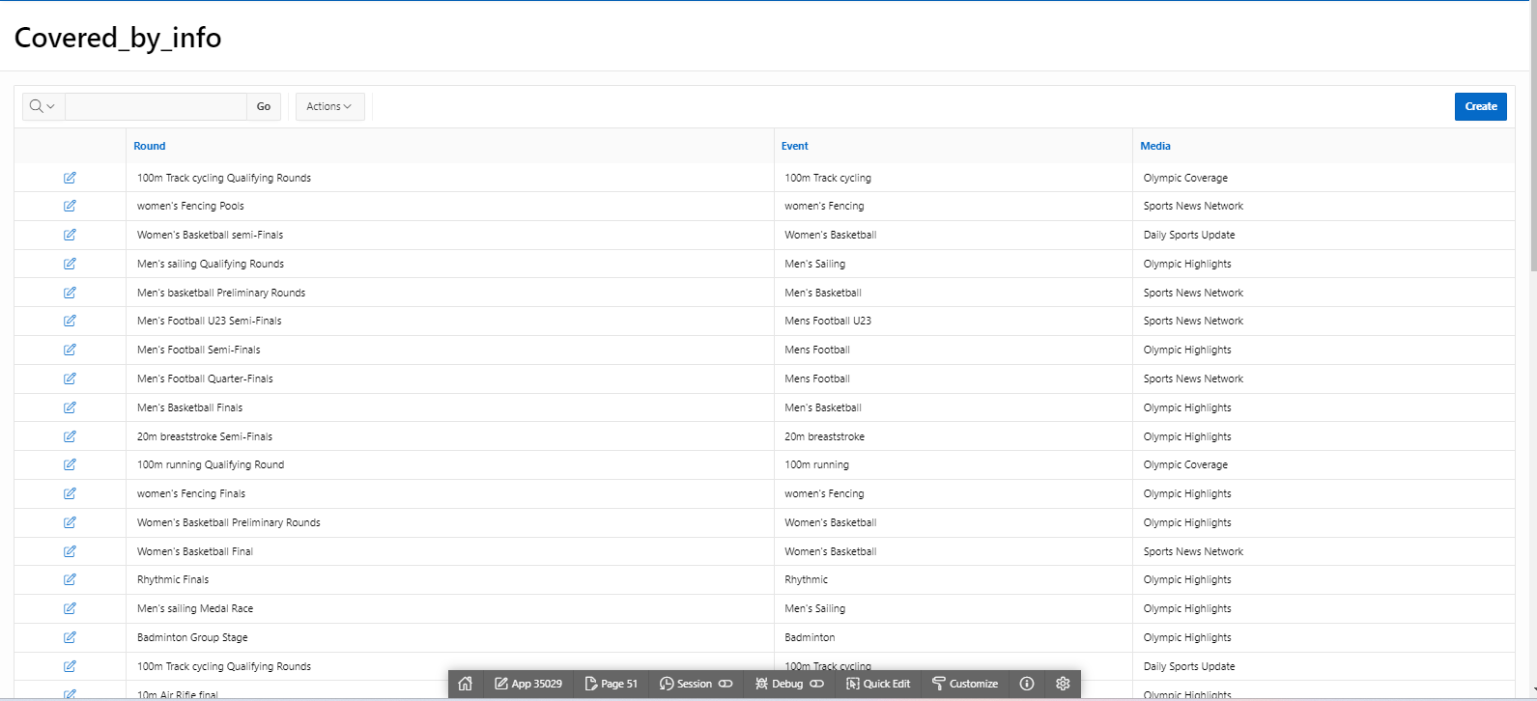
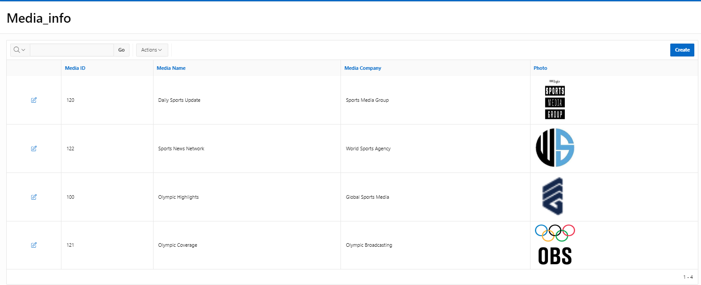
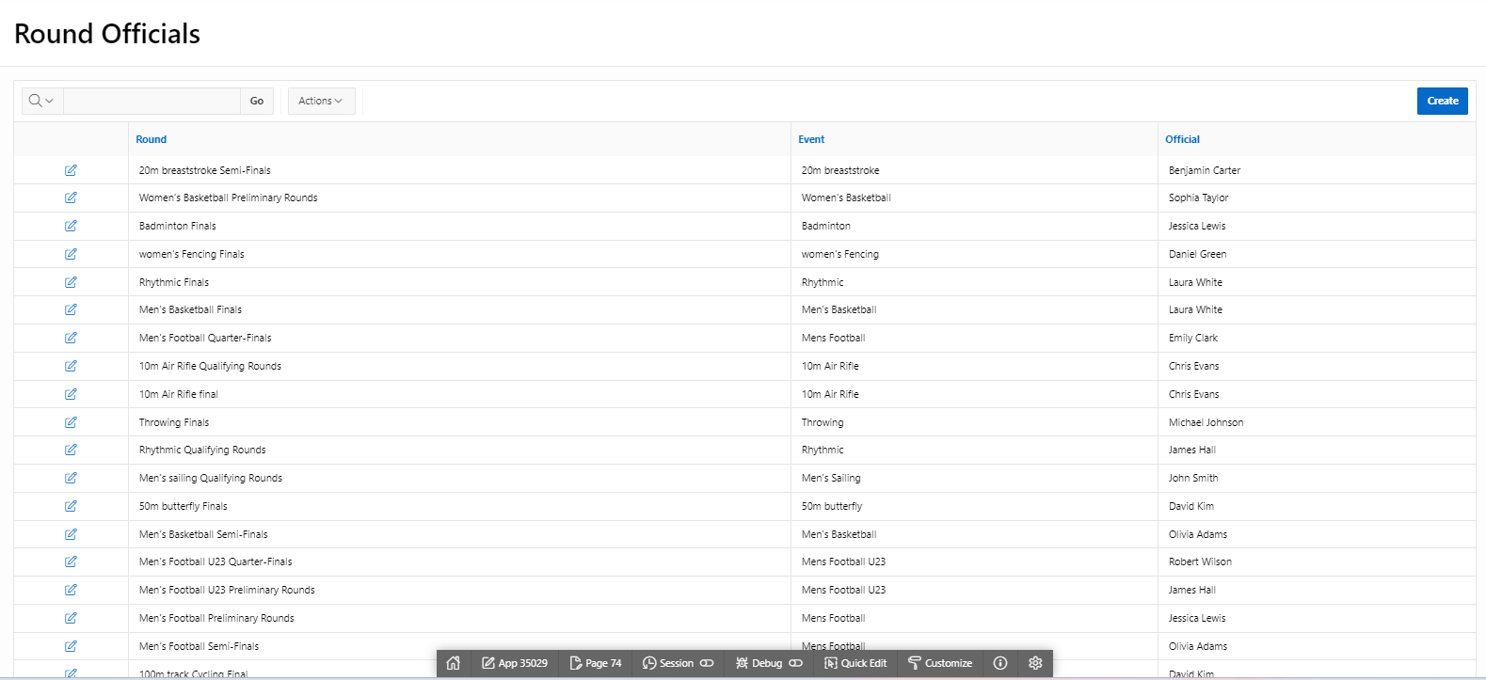

Master-Detail Form

Page Number and Name | Master Table (Parent) | Detail Table (Child)
29 – Team_member_list | Teams | Athletes
40 - Find all your events | Events | participates_in, Rounds
68 - Athletes winning info | Athletes | Results, participates_in
76- Venue Information | Venues | Volunteer, rounds
80- All round Info | Rounds | Supports, covered_by, Round_officials

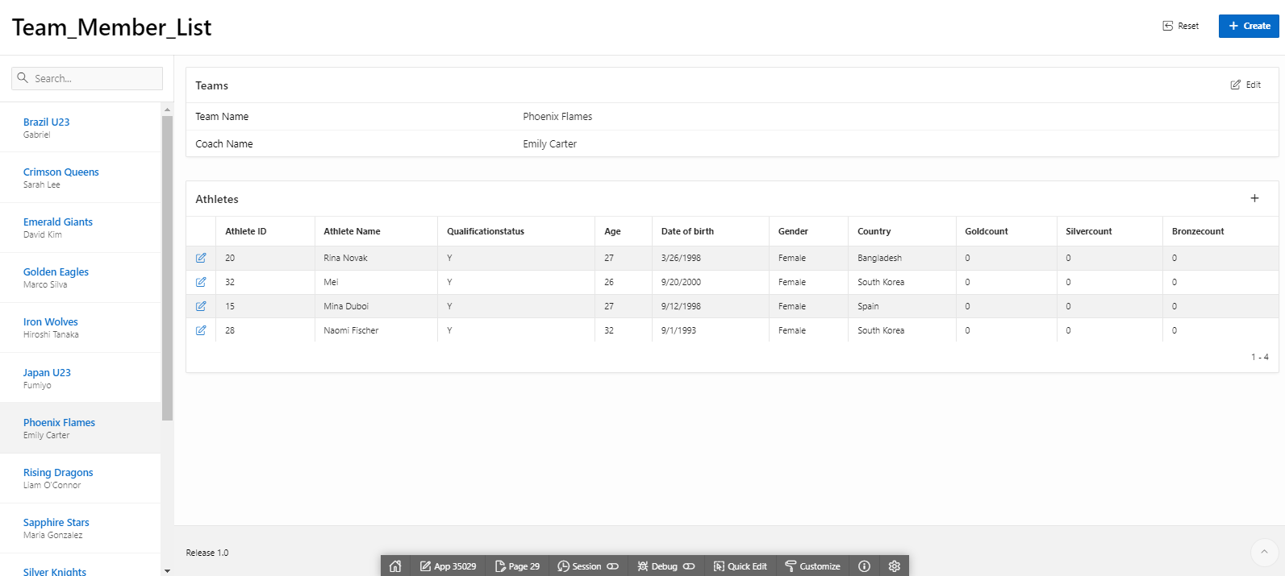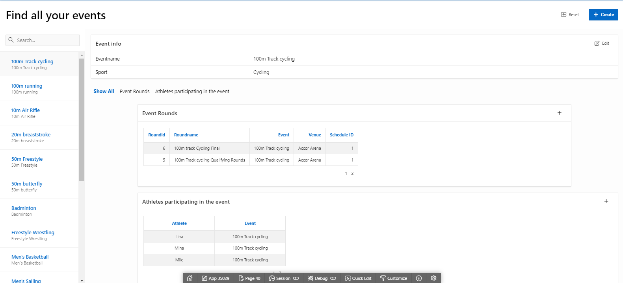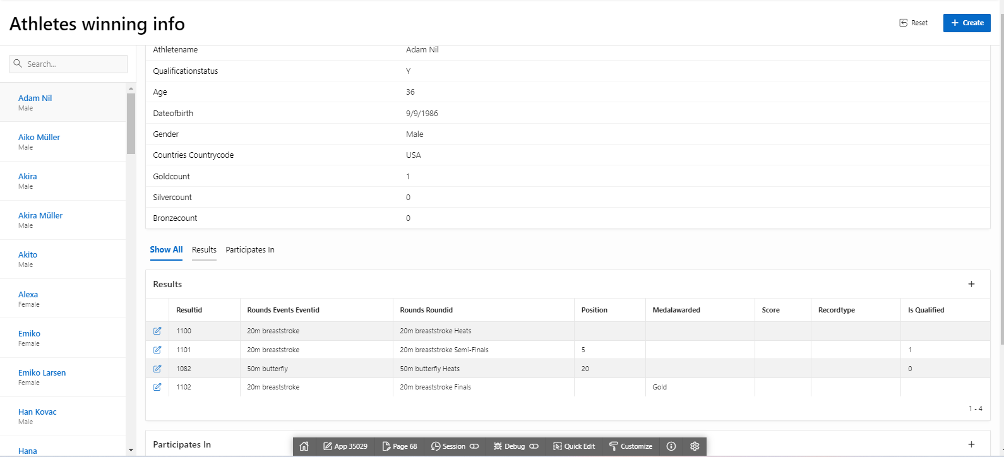
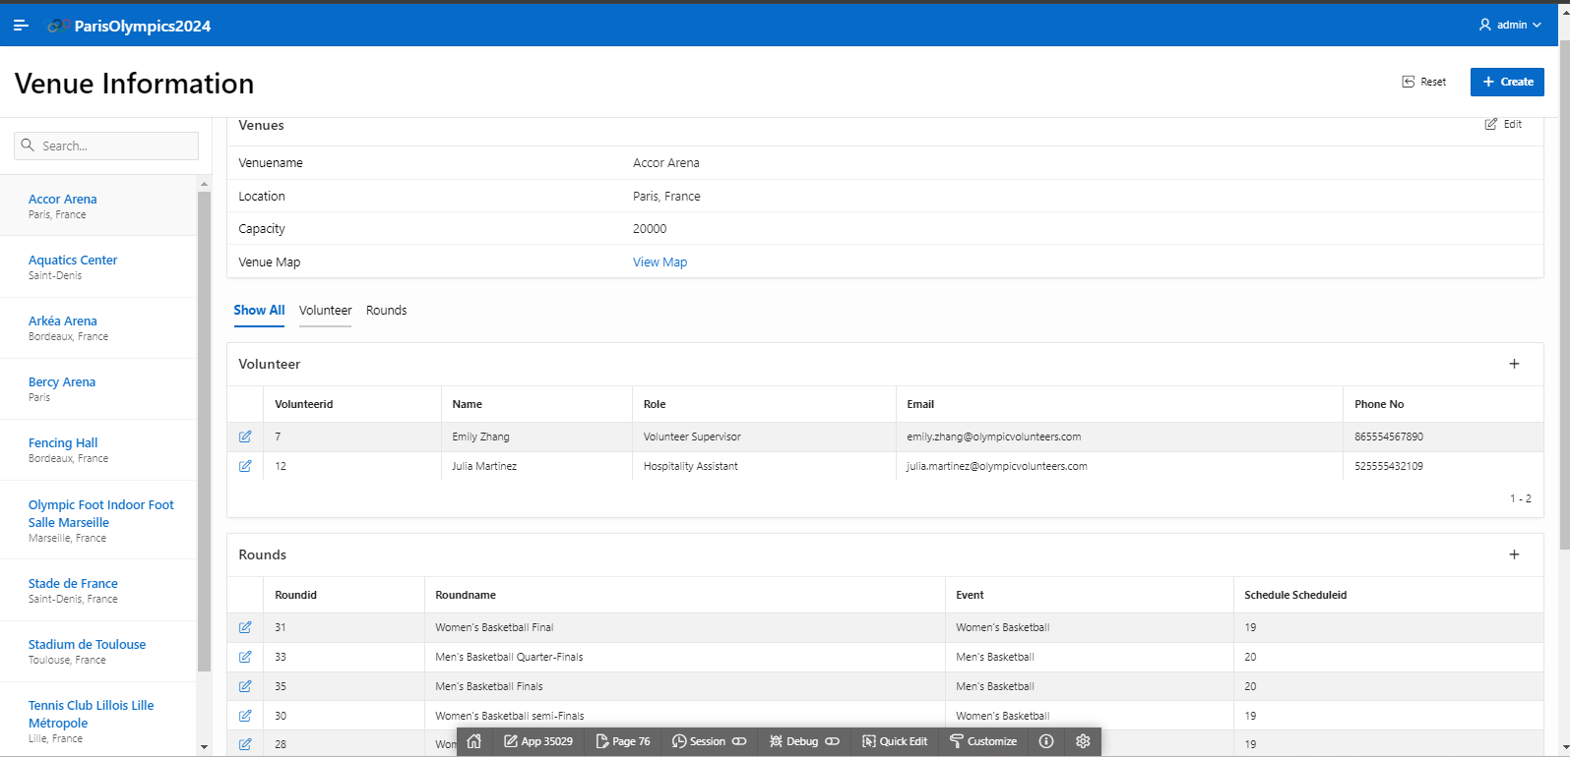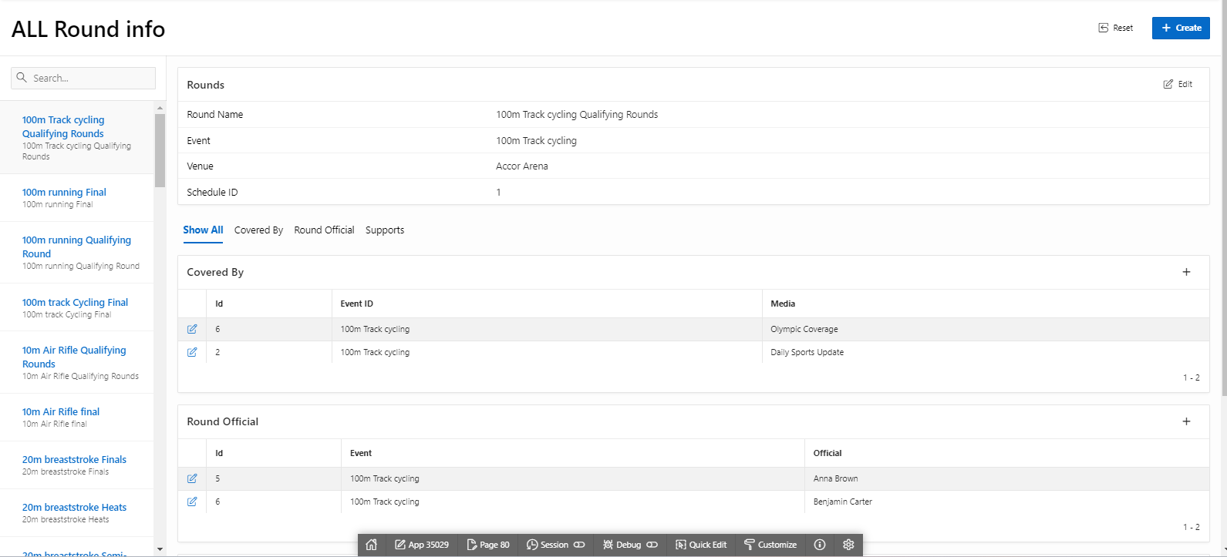

Reports based on Multi-Table and Aggregate Queries

Page Number and Name | Query Type | Report description
11 - Athletes and their disciplines | Multi-table | This report shows Athletes, country and their disciplines
16 - Medal Table | Multi-table | This report shows Athletes, country, disciplines, and all types of medals
53 - Medal Table (country wise) | Multi-table | This report shows countries , and all types of medals

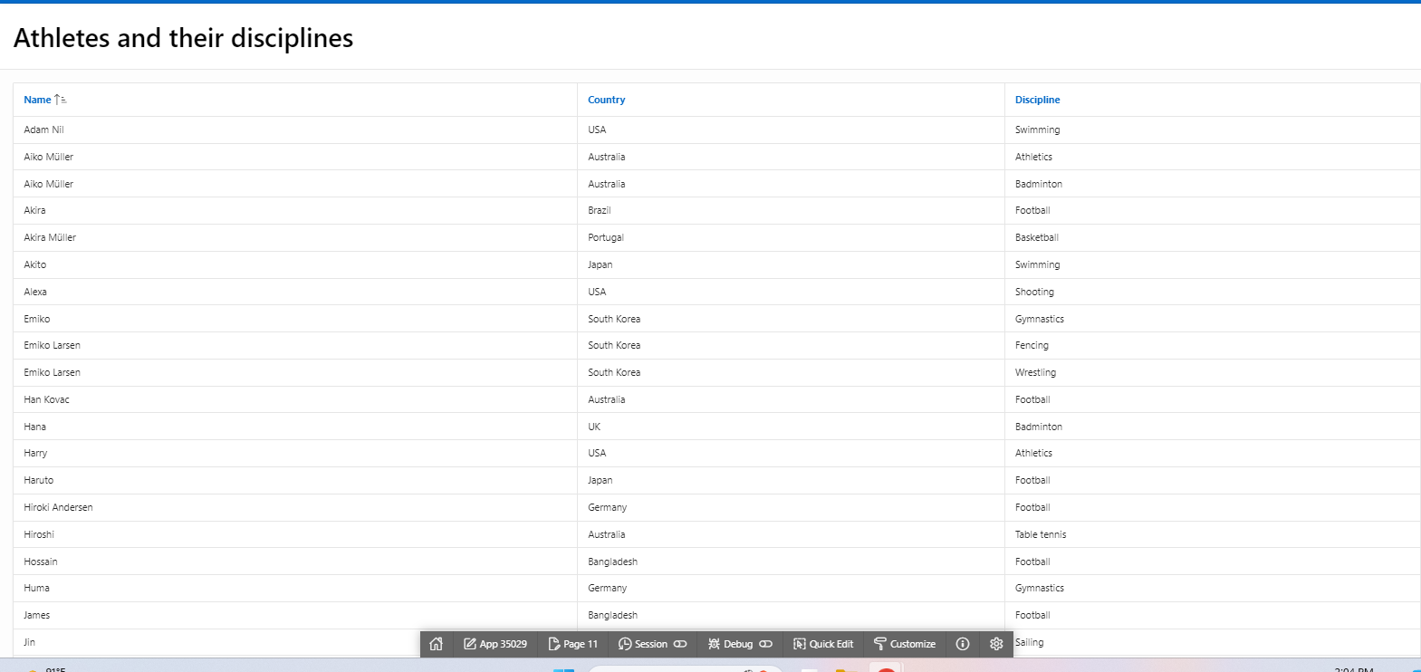
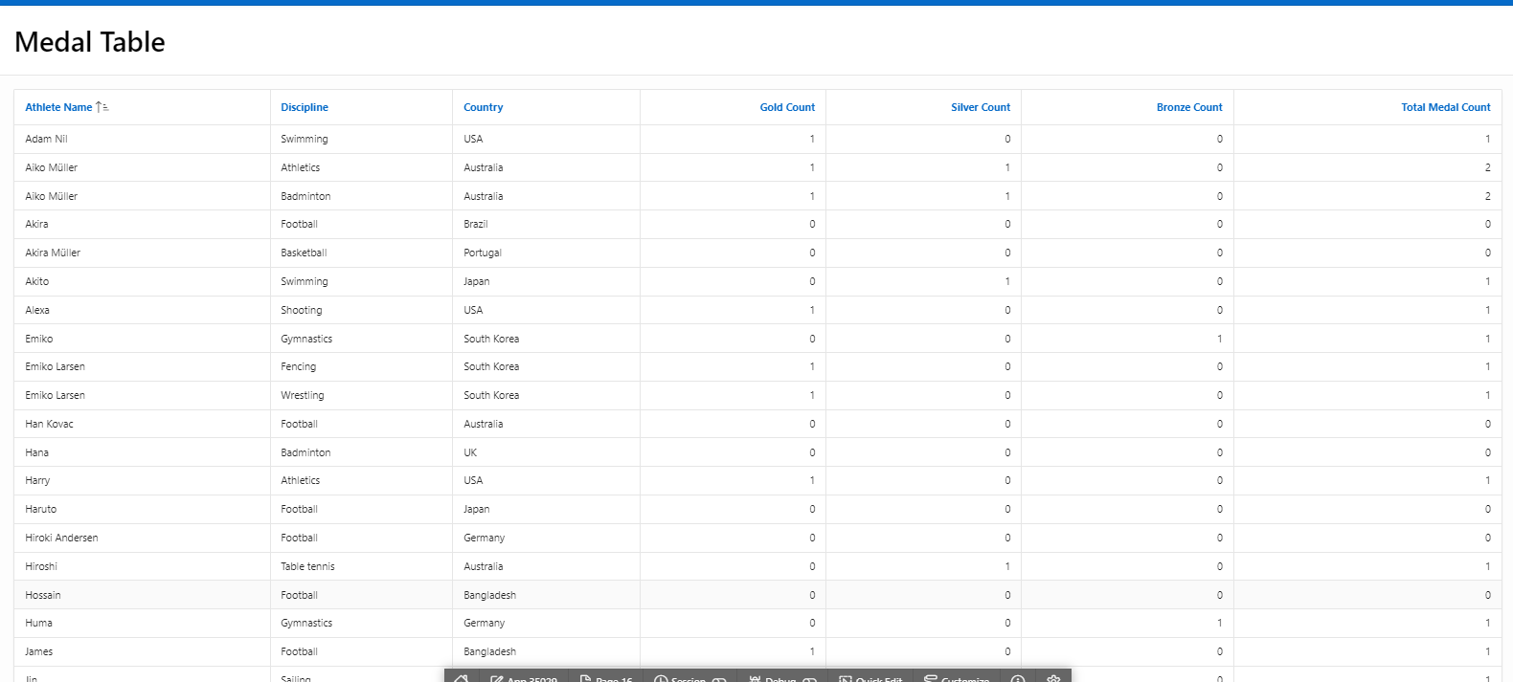
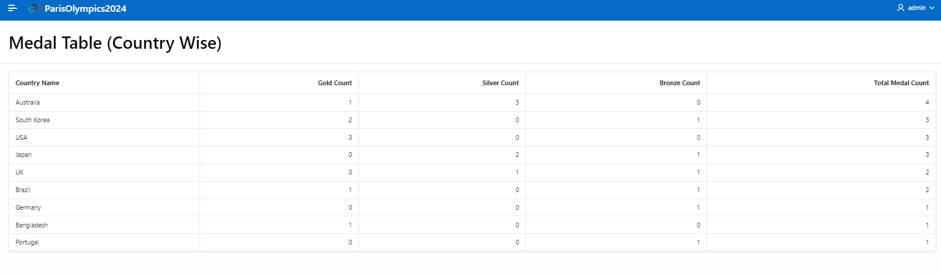

Parameterized Reports

Page Number and Name | Given Input | Report description
8 – Medal Achievement Report | Country name | This page lets user see the result of the given country in olympics

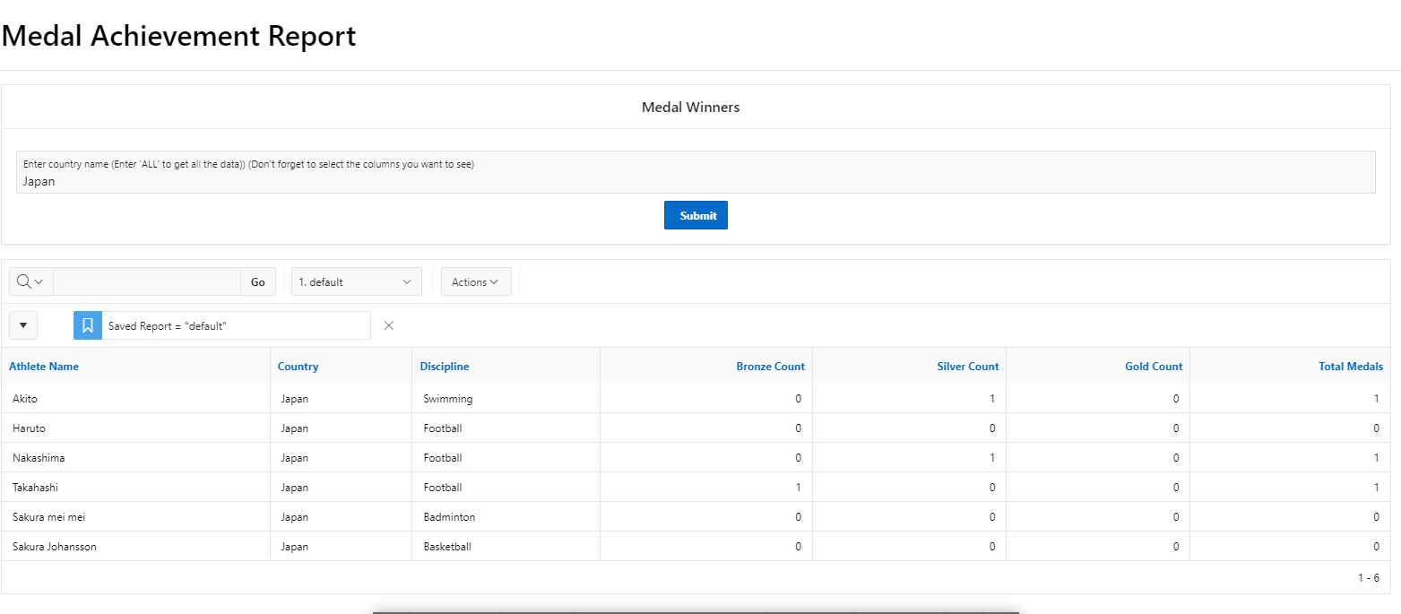

Charts and Other Pages

Page Number and Name | Chart description
38 – Country wise medal count | It is a Dashboard that shows 4 graphs in one page  - 1 – country wise total medal  - 2- country wise gold medal  - 3- country wise silver medal  - 4- country wise bronze medal
73 – Schedules | Legacy calendar  It shows the Schedules in calendar
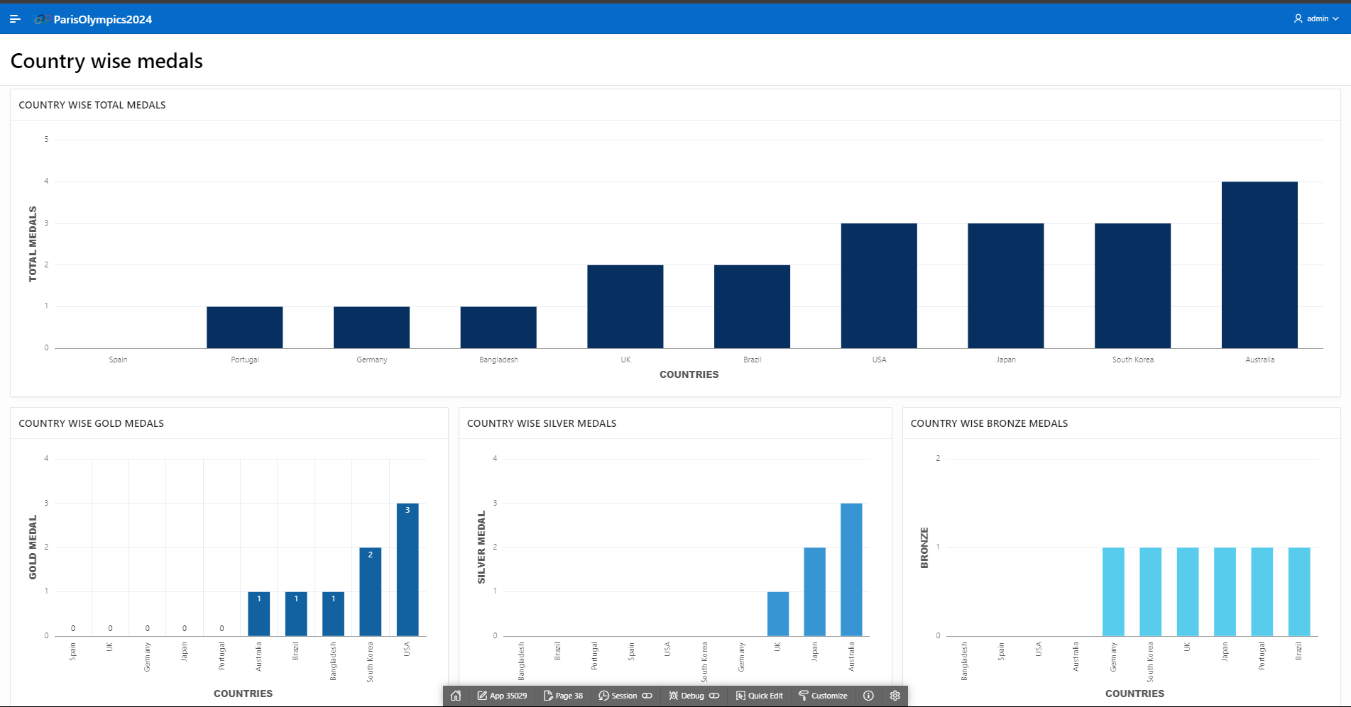
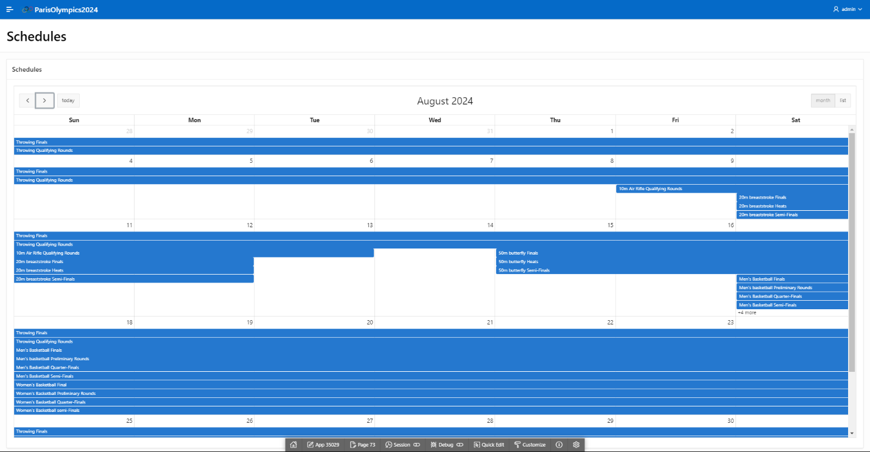

Authorization and User Role Assignment

User Role Assignment

User name | Password | Role
admin | lemmein | Administrator
Manager | lemmein | Contributor
Reader | lemmein | Reader

Page-wise Authorization Information

Page number and name | Authorization Level
P1. Home | Reader
P10000: Administration | Administrator
P2: OFFICIALS | Reader
P3:Official form | Contributor
P4:Athlete_Info | Reader
P5: Athlete_Form | Contributor
P6: Country_info | Reader
P7: Country_Form | Contributor
P8: Medal Achievement Report | Reader
P9: Sponsors | Reader
P10: Sponsors form | Contributor
P11: Athletes and their disciplines | Reader
P12: Event_Info | Reader
P13: Event_Form | Contributor
P14: Round_Info | Reader
P15: Round_Form | Contributor
P16: Medal Table | Reader
P18: Sports_Info | Reader
P19: Sports_Form | Contributor
P20: Venue_Info | Reader
P21: Venue_Form | Contributor
P22: Volunteer_Info | Reader
P23: Volunteer_Form | Contributor
P26: Tickets | Reader
P27: Team_info | Reader
P28: Team_form | Contributor
P29: Team_Member_List | Reader
P30: Teams | Reader
P31: Athletes | Reader
P32: Schedule_info | Reader
P33: Schedule_form | Contributor
P34: Ticket_form | Contributor
P35: buy_a_ticket | Reader
P36: Results | Reader
P37: Results_form | Contributor
P38: Country wise medals | Reader
P39: events | Contributor
P40: Find all your events | Reader
P41: Events | Contributor
P42: Rounds | Reader
P43: Participates In | Reader
P44: Athlete Event Participation | Reader
P45: Athlete Event Participation Form | Contributor
P46: Athletes | Contributor
P47: Supports | Reader
P48: Supports_form | Contributor
P49: Results | Contributor
P50: Results | Contributor
P51: Covered_by_info | Reader
P52: Covered_by_form | Contributor
P53: Medal Table (Country Wise) | Reader
P55: Media_info | Reader
P56: Media_form | Contributor
P60: Support_form | Contributor
P62: Rounds | Contributor
P65: Covered By | Contributor
P68: Athletes winning info | Reader
P69: Athletes | Contributor
P70: Results | Contributor
P71: Participates In | Contributor
P73: Schedules | Contributor
P74: Round Officials | Reader
P75: Round Official Form | Contributor
P76: Venue Information | Reader
P77: Venues | Contributor
P78: Volunteer | Contributor
P79: Rounds | Contributor
P80: ALL Round info | Reader
P81: Rounds | Contributor
P82: Covered By | Contributor
P83: Round Official | Contributor
P84: Supports | Contributor

Concluding Remarks

Atkiya Maisha :

Building this application was fun, but the most difficult part was designing the schema. We initially faced challenges with creating the ER model, and as we built the application, we noticed flaws in our diagram. The second most difficult part was data entry. For example, to input data into the results table, we needed information about the athlete, event, and round. Similarly, creating a round required data about the event, schedule and venue, which made the process quite tedious. Thankfully, my teammate had incredible patience and entered a significant amount of data, which now makes our application look well-organized.

Mohua Akter:

I really enjoyed working on this project because it was one of my most detailed ones. We aimed to make it look like the official website. We included 47 rounds, 55 athletes, and a lot of other official info, which took a lot of effort to gather data and find good photos. Creating reports and pages was challenging, especially with primary key errors, but my team-mate helped fix those. I learned a lot about buttons, data types, and chart design, explored features and I spent long hours working, especially during the last few days. Overall, I loved the experience and appreciated the support from my faculty and my friend.

